Session 3 -1

import java.util.LinkedList;

class MyHashSet {
private static final int BASE = 769;
private LinkedList<Integer>[] data;

@SuppressWarnings("unchecked")
public MyHashSet() {
data = new LinkedList[BASE];
for (int i = 0; i < BASE; ++i) {
data[i] = new LinkedList<Integer>();
}
}

public void add(int key) {
int h = hash(key);
for (Integer element : data[h]) {
if (element == key) {
return;
}
}
data[h].addLast(key);
}

public void remove(int key) {
int h = hash(key);
for (Integer element : data[h]) {
if (element == key) {
data[h].remove(element);
return;
}
}
}

public boolean contains(int key) {
int h = hash(key);
for (Integer element : data[h]) {
if (element == key) {
return true;
}
}
return false;
}

private int hash(int key) {
return key % BASE;
}
}

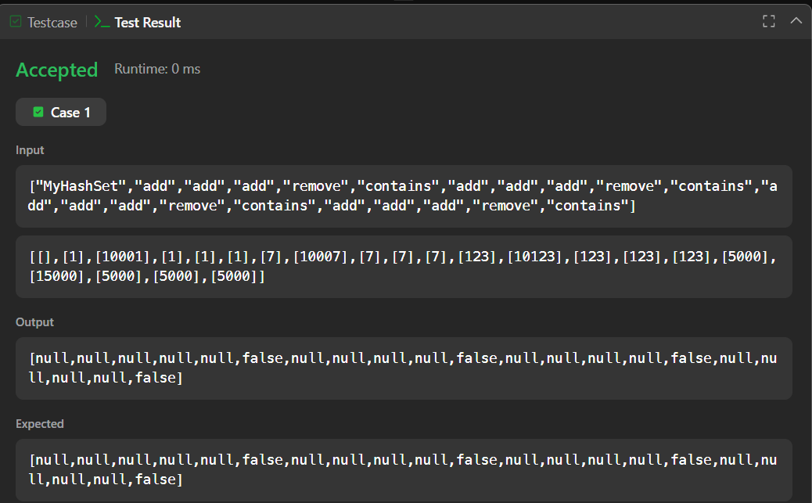

Session 3-2

import java.io.*;
import java.util.*;
import java.util.stream.*;
import static java.util.stream.Collectors.joining;
import static java.util.stream.Collectors.toList;

class Result {

public static List<Integer> gradingStudents(List<Integer> grades) {
List<Integer> roundedGrades = new ArrayList<>();

for (int grade : grades) {
if (grade < 38) {
roundedGrades.add(grade);
} else {
int nextMultipleOfFive = ((grade / 5) + 1) * 5;
if (nextMultipleOfFive - grade < 3) {
roundedGrades.add(nextMultipleOfFive);
} else {
roundedGrades.add(grade);
}
}
}

return roundedGrades;
}
}

public class Solution {
public static void main(String[] args) throws IOException {
BufferedReader bufferedReader = new BufferedReader(new InputStreamReader(System.in));
BufferedWriter bufferedWriter = new BufferedWriter(new FileWriter(System.getenv("OUTPUT_PATH")));

int gradesCount = Integer.parseInt(bufferedReader.readLine().trim());

List<Integer> grades = IntStream.range(0, gradesCount).mapToObj(i -> {
try {
return bufferedReader.readLine().replaceAll("\\s+$", "");
} catch (IOException ex) {
throw new RuntimeException(ex);
}
})
.map(String::trim)
.map(Integer::parseInt)
.collect(toList());

List<Integer> result = Result.gradingStudents(grades);

bufferedWriter.write(
result.stream()
.map(Object::toString)
.collect(joining("\n"))
+ "\n"
);

bufferedReader.close();
bufferedWriter.close();
}
}

